Growing Up In Austin

1934-1960

Carole McIntosh Sikes
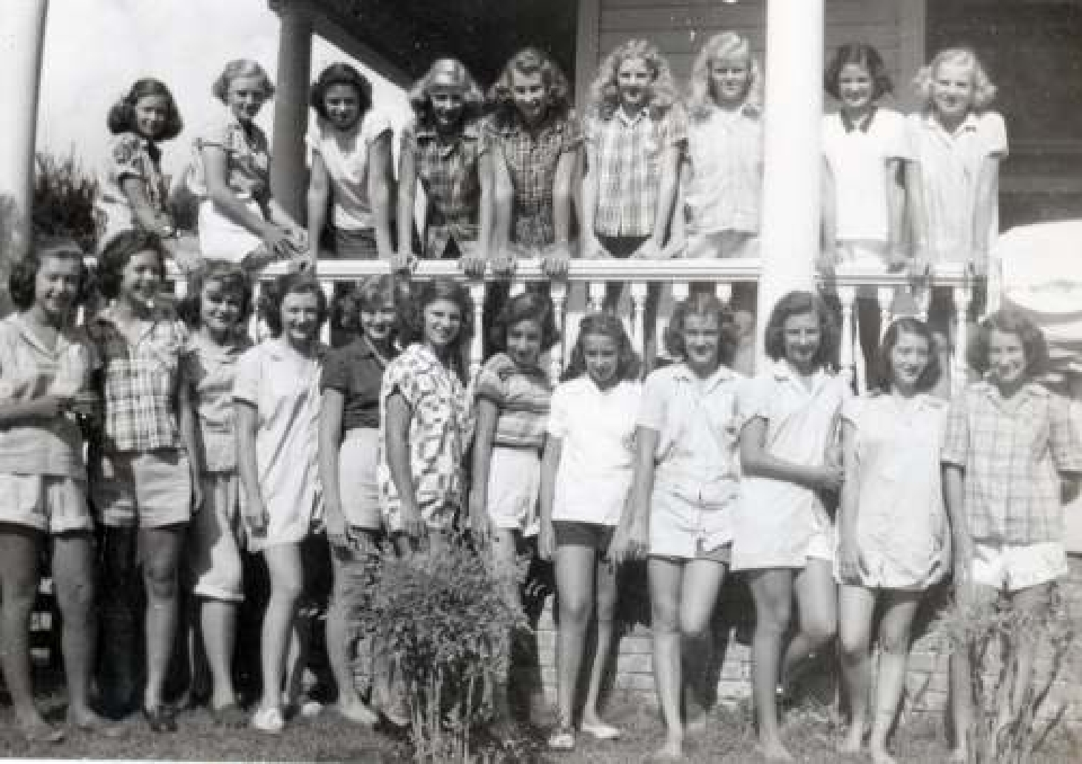

GROWING UP IN AUSTIN

A story for my grandchildren

Jeanne Carole McIntosh Sikes

Introduction

Novelist John Updike wrote, “The impulse to send postcards is wide spread, as is the desire to make a record of one’s transient life.” Dear grandchildren, as you read this statement you may say that there is no impulse to send post cards, or even, “What is a postcard?” This is because cell phones, the Black Berry, the iPhones and iPads, and all the other instant ways of communication have made letter writing obsolete.

At age 75, in the year 2009, I have virtually abandoned letter writing in favor of emails. However, I do enjoy writing chronicles of things about which I have first hand knowledge and experience. And it is my wish that when you are old ladies and old gentlemen, you will have an impulse to chronicle your lives and experiences for your grandchildren and whoever might be interested in learning how lives were lived in the past.

I don’t know if one can really remember the very early years. I suspect that I can remember mine because my mother, Georgia Bassett McIntosh told me those stories. She was a wonderful story teller and had an astonishing recall of names, dates and places. She loved nothing better than to take center stage with tales of all kinds. This was more evident in her old age when she became deaf, with hearing aids in both ears. The best way for her to enter into a conversation was to get the floor and keep it. I treasure the stories that she told me about growing up in the small east Texas towns of Kemp and Kaufman Texas, during the beginning years of the twentieth century.

Austin, Texas has been home to me all my life except for a summer session in New York City at Columbia University and the years 1956 and 1957 when I was teaching in San Antonio at Longfellow Junior High School. Also in 1969, Charles and I lived in Dallas for one year with our two young children Laura and Stuart.

In 1969 my husband, your grandfather “Dad Charles”, was offered a job by art gallery owners Don Vogel and Vincent Carozza. He became the first director of Main Place Gallery in downtown Dallas. Because I was a mother with small children, I told Charles to tell everyone in Dallas that I was an invalid and therefore would not be attending the cocktail parties and art openings. Of course this wasn’t true and he didn’t. Because I had been an active member of the Austin Junior League, I’m sure Vogel and Carozza thought I might be an enthusiastic asset to my husband as he represented the new gallery to Dallas society. In less than a year Charles knew he would rather be in his family’s Austin retail business selling diapers and baby furnishings, than to be in Dallas working for someone else selling fine art.

So back we came to Austin to buy the Bo Peep Shop from Chester and Gertrude Sikes, and yes, cloth diapers were a big item because we were not yet entirely into the throw- away culture; babies wore cloth diapers every day. Our purchase of the store provided the senior Sikes, Chester and Gertrude, with retirement income and us with a fine living in the wonderful city of Austin. Before retiring to live on Lake Travis, Charles created two more stores called Expecting the Best for maternity and infant wear.

In my later years, while reading books like Oh Pioneers by Willa Cather, I realized how much I enjoy learning about times gone by. I have written about our ancestors in my story, “The Bassett Farm” and I now will regale anyone who will read this with stories of my youth growing up in a town of a population from 40,000 to 60,000. Austin was a very different place than it is now as I finish this story in the year 2011.
At the invitation of my friend Dr. Ruth Morgan, retired provost of Southern Methodist University, this story will be deposited, along with the The Bassett Farm story and my other papers, in the Archives of the Women of The Southwest, a collection in the DeGolyer Library on the campus of Southern Methodist University (SMU) in Dallas, Texas. Ruth created the archives so that future generations of students might learn what it was like to live during earlier times in Texas and the Southwest. What follows is part of my story.
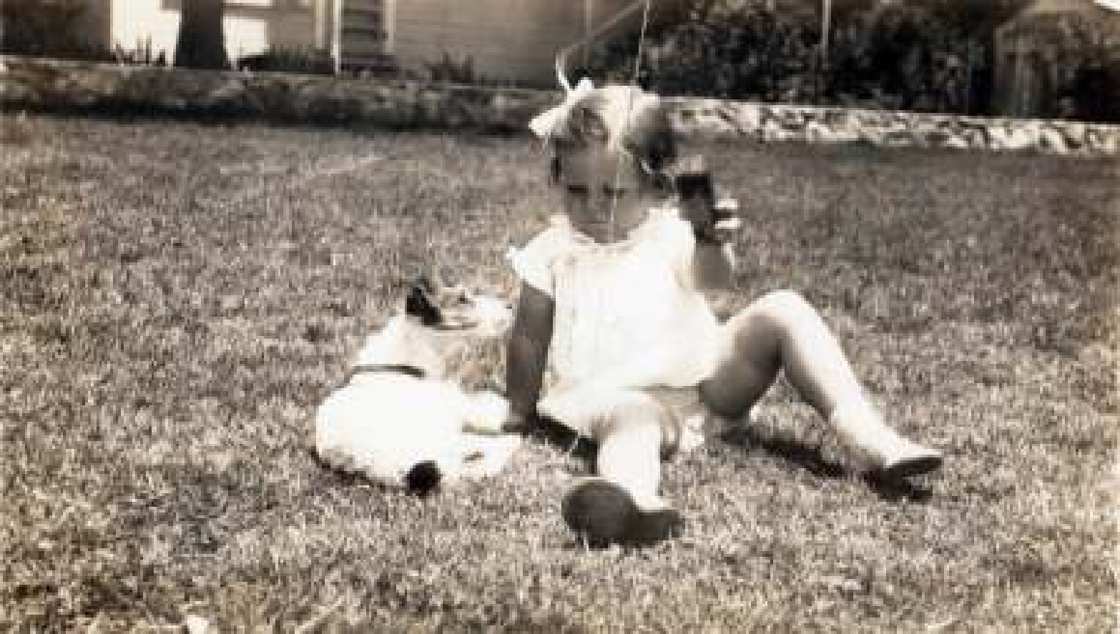

Carole with Rag-A-Muffin

The First Five Years

As the only child of Georgia Bassett McIntosh and Sidney Carroll McIntosh, I was born September 10, in the year 1934, in Austin, Texas. I remember vividly the house on Hemphill Park, where I lived as a three, four, and five year old. My parents rented the small brick cottage with two bedrooms and one bath that was owned by Mrs. Stewart, the mother of one of my mother’s good friends. The rent was probably around $40.00 a month. If that sounds like a deal, consider this: My 42-year-old father at that time was chief engineer of the Gas Utilities Division of the Railroad Commission for the state of Texas, and I’m guessing his salary was not much more than 300.00 a month. This job had nothing to do with railroads. His job was to see that the companies supplying liquefied petroleum gas to users in the state were following all the rules and regulations for safely storing and transporting this new heating material.

While he was a student at Purdue University and the University of Michigan, playing football and studying Civil Engineering, young Sidney Carroll McIntosh (Mac) also took elective courses in wood working. This was his creative outlet just as my mother’s was selecting fabrics and sewing clothes for me. Each time we moved, my dad would set up his lathe, a motorized sanding wheel and work table that folded into the wall of the garage. Old pipe tobacco tins were filled with screws, nuts and bolts and arranged neatly on shelves over his work table. This work space was very intriguing for me as a child.

Mother was meticulous about her housekeeping. From time to time she would put the bed mattresses out on the porch in the sun so that the long staple cotton would fluff and smell fresh. Clothes were hand washed and ironed at home. Towels were hung on a clothes line in the sun but the sheets were tied in a bundle and left on the front porch for pick-up by the Austin Laundry and Dry Cleaning
service. I knew of no one with a washing machine, and there were no Laundro-Mats with coin operated machines. One day after the sheets were bundled and put outside, we missed my tiny pet kitten. We called and called and finally found him tied up in the laundry on the porch. Fortunately, he missed a ride in a truck to the Laundry and Dry Cleaning store.

Carole and Bobby

In front of our house there was a big loquat shrub providing a shady place to hide. One day my playmate, Bobby, and I were playing beneath the dense foliage. Mother discovered us playing doctor and nurse, discovering our anatomical differences. My mother and Bobby’s mother levied a punishment of 6 weeks without playing together. Later when we both were in Austin High School with only one grade between us, I wondered if he remembered our early childhood experiments in

physiology.
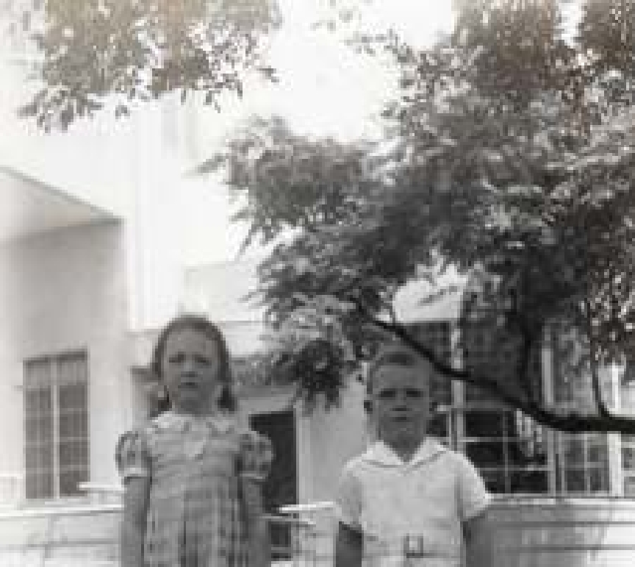

Bobby’s father had been born in Germany. For his family of five in Austin, Herbert Bohn built a very remarkable hose of the international Bauhaus style on West 29th street. It was great fun to play at Bobby’s big house. There was a round opening between the living and dining rooms with an electronic closure that caused the door to disappear into the wall. Another amazing feature was a glass enclosed solarium with a big goldfish pond in the center.

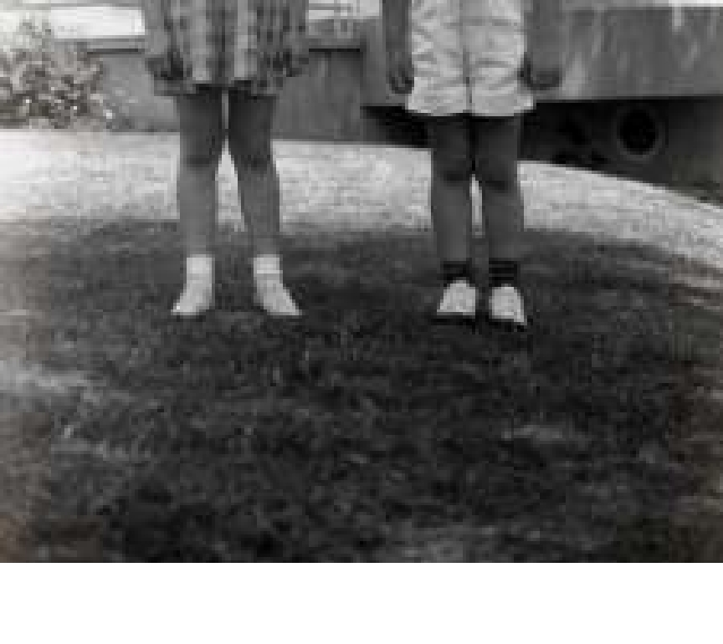
Bobby was four and I was five when his older sister married. Before the wedding, as was the custom of some German families, a mock wedding was enacted at the party given by the family of the bride. Bobby was dressed in short white pants and wore a summer straw hat just like all the men were wearing at that time. I, as the mock bride, was dressed in my finest as I rode around the yard with Bobby in a miniature car with a small suitcase tied on the bumper. I’m told the guests were entertained seeing two small children playing like a grown-up bride and groom.

A German-American couple with the unfortunate name of Goebbels lived next door to us. Their name was the same as that of Adolph Hitler’s comrade who after World War II was tried and condemned as a war criminal. During this period between the first and second World Wars, there was much fear and suspicion of Nazi Germany and
of anyone with a German name or accent. My mother befriended this young couple who had so very few friends. They were nurturing to me, inviting me to play in their beautiful gazebo with a sawdust floor and a ping- pong table in the center. It was great fun to swat at the little white balls as well as to be the ball person when the Goebbles were playing a game. They were especially amused when watching me play with my dolls, Charley McCarthy and Gorgeous. My Charlie McCarthy doll was a replica of the dummy that ventriloquist Edgar Bergen used to entertain national audiences. Gorgeous was a doll comparable in size to Charley and truly elegant in costume. The neighbors related an episode to my mother about Gorgeous frantically calling Charley to come home because she was pregnant. At age four, I’m sure that I didn’t know what that meant but I had heard adults exclaim, “She’s pregnant !”

Our street, then named North Guadalupe Street and now called Hemphill Park, actually was a double street just north of the University of Texas campus. An open creek in between the twin streets ran for four blocks between East 30th and 34th streets. The creek was bridged once in that span before it ran underground through huge concrete culverts. The embankment on either side of the creek was lined with flagstones of native rock, and the grass above was mowed by the city. For me, the culverts were large enough to walk into. They were great fun to explore. There was a very keen sense of danger mixed with the excitement of doing something with other children in the neighborhood that we knew our parents would not allow us to do. It is interesting to note that I had much more freedom to play in my neighborhood unattended by adults than my grandchildren have had. My favorite neighborhood friends were twin girls about three years older than I. Mary and Sally Hall taught me to roller skate on the sidewalk in front of their house. They lived on Laurel Lane at the top of a hill. It took lots of courage on my part and patience on theirs to get me rolling down the steep incline on wheels without brakes, strapped to my feet. The only way we were able to stop before careening into the street at the bottom of the hill was by rolling into a flower bed. You can imagine the reception we got from the lady whose garden it was when we left our skate’s imprints in the soft tilled earth in her garden. We just hoped fervently that she was not home on our skating days.
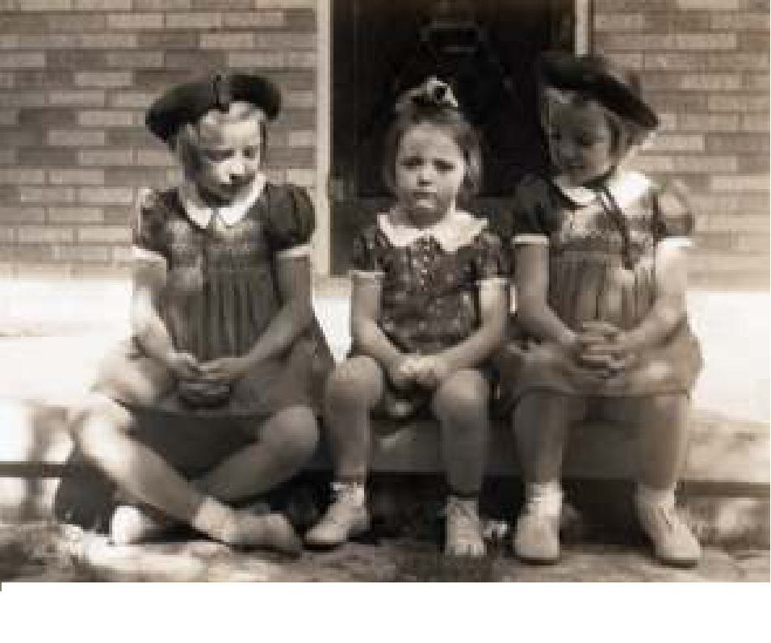

The Hall twins with Carole on her front porch

Sadly, the freedom that I had as a child during the late 1930s and the 1940s no longer exists for children. There was very little crime in Austin. Doors were left unlocked so the milk man could come down the alley to the back door and put the glass bottles of milk into the ice box. Milk was not homogenized and there was about two inches of wonderful cream in the top of each bottle. The used glass bottles were taken back to the dairy, sanitized and refilled for delivery in the next days. Many neighbors still had blocks of ice delivered to be put into their ice boxes. Most of us who had small electric refrigerators in our kitchens for keeping things fresh still called them “ice boxes”.

I never had a lemonade stand, but my daddy encouraged my entrepreneurship by going to the ice house and then to the Coca Cola bottling company to set me up in the front yard with cokes to sell to passers-by on Hemphill Park Street. The big red and white Coca Cola sign was larger than the orange crate “counter” on which it was nailed. It stuck out on either side of me as I sat expectantly and timidly waiting for customers to stop and pay me a nickel for a bottle of Coke. The retail price of cokes purchased in the stores was five cents. So after buying the cokes and then the ice and building my stand, my father was losing money while I was making it.
However, it wasn’t all fun and games during those first five years. As I’ve already mentioned there was punishment for my unwise decisions when discovered and there were losses usually brought on by my inexperience and carelessness. My mother used these occasions to teach me responsibility and correctness. When I was especially cantankerous she would scold, go outside, pluck a limp green switch from a shrub, peel off the leaves and bring it back inside. This usually was enough to bring me back in line. When she actually used the switch, the sting was not from her ineffective implement but from my chagrin and embarrassment. I mentioned the loss of play days with Bobby. One day another playmate and I decided to entertain ourselves by throwing rocks at passing cars. Of course, I’m sure it was Paul’s idea but I was a willing accomplice. Needless to say, my mother was horrified when an irate woman screeched her car to a stop and knocked on our door to relate what had happened. No doubt there was a dent in the woman’s car for which our parents had to pay. And to be sure, we were scolded and punished in some serious way when we returned from hiding.

One Sunday afternoon my mother and father and I drove to the near-by town of Bastrop to visit some friends of my parents. I was a shy little girl and was probably miserable at the prospect of spending the afternoon in the company of adults whom I didn’t know. I’m sure I complained and Mother placated me with permission to take Betty Boop along on the trip. How devastated I was when almost home that evening I realized that I had left my doll in Bastrop. My parents would not turn the car around to retrieve Betty Boop so I had to cry myself to sleep that night.

Another loss was the death of our little fox terrier, Rag-a-Muffin. Then I lost my huaraches from Mexico because I left them out in the sand box and the rain shrunk them so much they wouldn’t fit my feet any longer. I believe I was more disturbed about the loss of Betty Boop and my favorite shoes than I was about the dog. I included these stories of loss, as well as notes about being punished, because children in my day were not pampered as much as some are today. It was parent’s duty to discipline and to teach their children that there are consequences for mistakes and errors in judgment. And no, I did not get another Betty Boop or new huaraches to replace those left in the rain. We did have other pets but Rag-a-Muffin was not immediately replaced.

My only living grandparent died when I was five years old. She was my mother’s mother. I remember visiting her home in Kemp, Texas. While in the back yard, I witnessed a black man ring two chickens’ necks, pick the feathers and take them into the kitchen to be cooked for our noon day dinner. As I

recall I was not able to eat much of that Sunday dinner. Note that I referred to my grandmother’s helper as a “black” man. However, when I was a child the word Negro was entirely acceptable. The slang “N” word was not, although unfortunately I certainly heard it used.
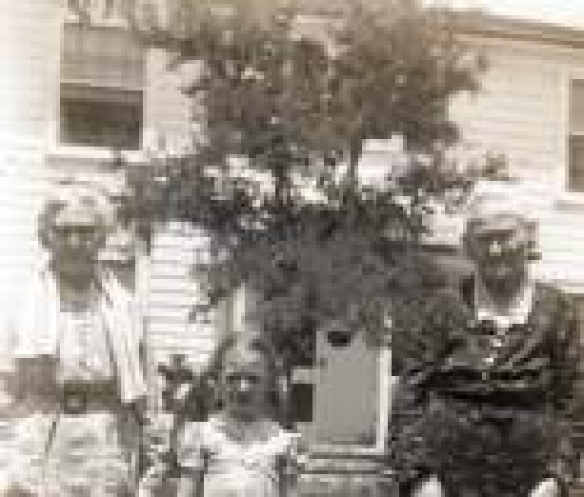

Carole with Great Aunt Mattie and Grandmother Annie
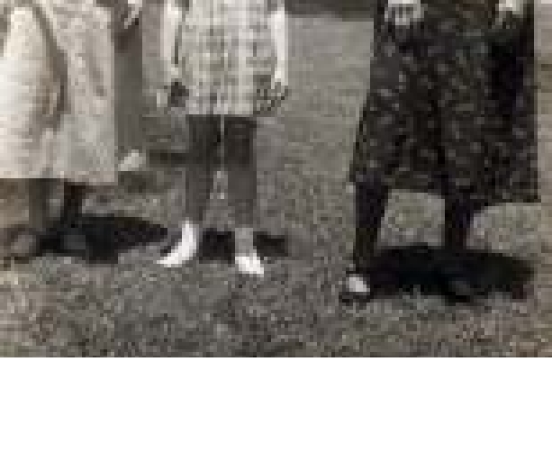
“Mamaw”, as my grandmother was called, visited us in Austin. I have no remembrance of that visit, but my father snapped a photograph of me with my great aunt Mattie Parmlee and my grandmother Annie Parmlee Bassett. To me they seemed to be very, very old ladies usually dressed in black dresses trimmed with lace. In truth they were no older than I am today, but I dress in pants suits and usually wear sandals or tennis shoes.

In those days so long ago, a penny actually would buy something. At the Kash Karry grocery store, Mother would give me a penny to buy a tiny paraffin wax bottle about two inches tall containing some colored, sugared water. After the water was consumed the paraffin could be chewed, but not swallowed, like chewing gum.

As a little child, Sundays seemed both good and bad. Sitting in my Daddy’s lap while he read the “funnies” to me was

wonderful. I loved Popeye, the Katz and Jammer Kids, Little Orphan Annie, Joe Palooka and Dick Tracy. The bad part was getting dressed up in my velvet dress with the scratchy lace collar and being dropped off at University Presbyterian Church. My mother and father belonged but did not attend church. However they thought it necessary for me to attend Sunday School, so I was sent with a nickel tied in a handkerchief for my offering. Many Sundays I was so timid and nervous that I chewed a hole in the handkerchief.

For one week, during the summer when I was five years old, I went to the Lutheran Church Vacation Bible School across Hemphill Park from our house. It was such a thrill to sing hymns while processing from outside the church, into and down the center aisle of the nave behind the cross and the American flag. At this early age, I loved the priest’s vestments and the colorful altar hangings and the ancient rituals of this liturgical church. I believe this early experience made a liturgical service seem very correct for me when I changed denominations, before my marriage to Charles Sikes, to the Episcopal Church of the Good Shepherd in Austin.

Aunt Bonnie Bassett
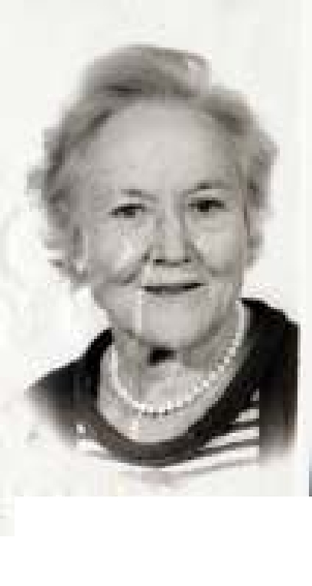
Hopkins

My mother had four sisters and one brother. A favorite, Aunt Bonnie and her husband Fred Hopkins lived in the new area of Austin called Tarrytown. It was an unconventional house. Actually, it was a garage apartment built on the back of a lot on which they planned to build a home when they could afford to do so. Bonnie loved her big kitchen, which was downstairs looking out on her rock terrace and rose garden. Upstairs was the living room over the garage, a bedroom and bath over the kitchen. Bonnie was like Tom Sawyer, who made working seem such fun. I dusted their furnishings inside and watered the roses and trees outside. Mother never understood, nor do I, how her sister got me to work with her all day and then come home feeling thoroughly entertained and delighted with the visit to my aunt’s house. This was a talent my Aunt Bonnie had. She exercised it on me in her later years when she could no longer do things for herself. I was the child she never had. She truly loved me as she might have loved a daughter of her own, and I was directed by her as she might have directed a daughter.
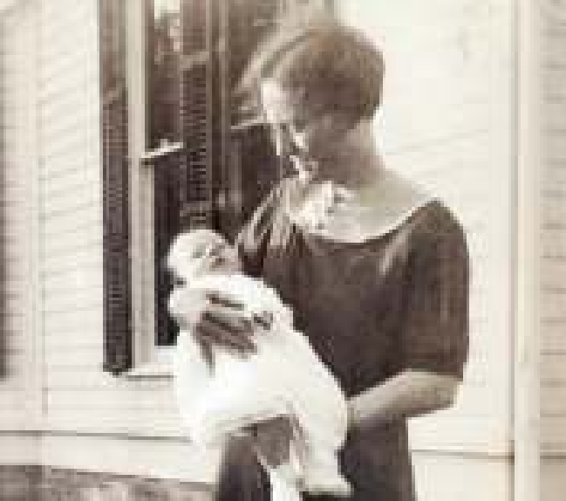

Bonnie and Fred had shared their first big Victorian home with my parents for several months after I was born. Today it still stands on San Gabriel Street near the University of Texas. Georgia and Mac had been married and childless for nine years while my father, the young engineer, took interesting jobs all over his newly adopted state of Texas. When, finally, my mother became pregnant, she insisted that they settle in one place. She was tired of boarding houses and small hotels in the little Texas towns to which her young husband was assigned by his employers. He worked on the levies on the Trinity River and in Dallas laying out the streets in a subdivision around White Rock Lake, then for a company in Wichita Falls mapping West Texas counties that had never been mapped and for the U. S. Geological Department setting bench marks in the Rio Grande Valley of Texas. My mother and father moved to Austin shortly before I was born. My father took a job with the state of Texas. The state reserved the job for him while he was away serving his country during World War II. When he returned he reclaimed and was made director. He retained it until his retirement. Unlike today, it was not at all unusual for men to stay in their professions and in the jobs they had chosen as young men until they were ready to retire and leave the workforce.

Georgia and baby Carole at 2210 San Gabriel Street
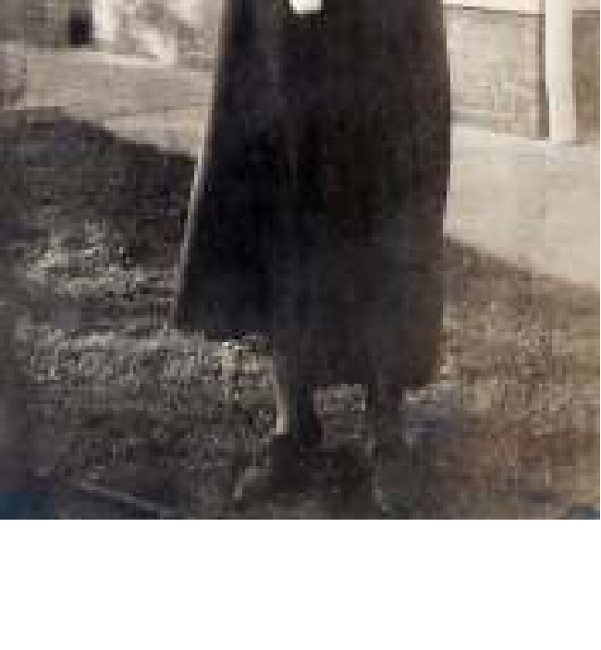

As a former history teacher, Mother was thrilled to come to the capital city of the state. She sat in the gallery of the State Legislature in the Capitol building, toured the French Legation and Elizabeth Ney Museum and explored many other favorite places in Austin. When Tommy Dorsey came to town, she dressed me up and took me with her to the train station to see the famous band leader. In 1935 the Tom Miller Dam on the Colorado River broke and the city was flooded as lake waters washed over the banks and into the streets. My father learned that there would be no water service for several days as a result of the catastrophe. He tried to telephone his wife. When no one answered he rushed home to fill all the bath tubs, sinks and containers with water. In those days baby’s cloth diapers had to be washed daily. When Mother arrived with me in her arms, she was questioned about where she had been. "To Congress Avenue to watch the water rise and experience the excitement" she said. I can only imagine the excitement that was created by that remark, in that household, at that time.

Another story told to me about my very early years had to do with a stranger who came to our kitchen door almost every morning. In those days men on the streets were called beggars or panhandlers. Many of them had lost their jobs and had no money as a result of the Great Depression of the 1930s. Often too old to find jobs, they had to knock on doors in hopes of getting something to eat. Today fewer people are at home in the daytime so the jobless, street people often stand at busy intersections in the city holding signs and hoping for a gift of money. Every morning an old man with a long white beard came to our back door and Mother gave him coffee and toast. At this time, I must have been no older than three, and I was fascinated with a man so unlike my daddy. He talked to me and entertained me on the stoop outside my mother’s kitchen door as he ate his breakfast. I was told that he was Santa Claus. Today I can’t imagine mothers trusting their young children to be entertained by a stranger at their door. However, in the late l930’s in the town of Austin, I suppose there was little or no fear of homeless beggars satisfied with a piece of toast and a cup of coffee consumed outside the screen door of the kitchen.

Most of these early stories of me as an infant and toddler are supported by photographs taken and tales told by my parents. However the following memories in the next sections of Growing Up In Austin are mine to claim. When I was five years old, we moved to a little French house on Fairfax Walk north of the University and east of our home on North Guadalupe Street and Hemphill Park. My parents were eager to enroll me in a new elementary school called Robert E. Lee. I entered the first grade shortly after my sixth birthday in September of 1940.

School Days

My first playmates, Bobby, Paul, and the Hall twins, were chosen by my mother. The first friend of my own making was Alison Gray. This enduring friendship has lasted to this day. Together we began the first grade in Robert E. Lee Elementary School, later we stood by one another in our weddings, and now, with other very dear Austin friends of many years, we enjoy weekly meetings at the lunch counter of Nau’s Drug Store. Our Thursday Lunch Bunch has been meeting for more than 30 years with no sign of stopping as long as we can drive to the pharmacy on West Lynn or unless they close their fountain service.

Children in the early l940s created their own activities and entertainment. Because most families had only one car, mothers did not drive their children all over town to lessons and sports activities. However, at age five, my mother enrolled me in ballet lessons in Janet Collett’s dance studio. In this class I met Kitty Harrison, who later became an elementary school friend. At our dance recital she was Miss Muffet and I was the spider who “sat down beside’r and frightened Miss Muffet away”. Costumed in old long black stockings that ripped during the dress rehearsal, I cried and refused to go on the next day because the audience had laughed when I was on stage. Mother went into action and her skills at the sewing machine enabled me to be a presentable spider, in a new costume, for the performance the next night.
Mother took Daddy to work on the days that she needed the car for errands and for taking me to lessons. After moving to Fairfax Walk and learning to ride a bicycle, Alison and I were allowed to ride our bikes to swimming lessons at the “ladies gym” on the campus of the University of Texas. Little green tank suits were issued to the young summer swimmers who were required to step through an antiseptic foot bath before entering the pool.

Polio, or infantile paralysis, was a tremendous threat to children before 1955 when Jonas Salk created an immunization for the disease. Public swimming pools and movies were off limits when there was an outbreak. Children with the disease were put into plaster body casts to prevent their spines from curving and collapsing. During a fundraising for polio research, I remember seeing a child whose lungs had collapsed. She was able to breathe only by living prone in an “iron lung” which was a long, horizontal iron tube, sealed from the world with only glass windows from which she could see her family and visitors. Pressurized air whooshed in and out causing her lungs to fill and release air at normal intervals. Today there are many parents who question the wisdom of immunizations for their young children. However, it is because of the routine shots given to infants that our country has been free from so many of the dreaded diseases that crippled children and caused many to die at an early age.

I rode my bicycle to weekly piano lessons. It was necessary to stand up on the pedals and pump up the long East 32nd Street hill to my music teacher’s house. Riding near my friend Kitty’s house on Red River Street and past what is now St. David’s Hospital and across Lafayette Street (later Interstate Hwy 35) was an adventure for me. On good days I liked the bike ride well enough, but I didn’t like the piano lessons. Mrs. Lane stuck golden star stickers in my music book when I practiced and played a piece to suit her. It was the practicing that caused conflicts between me and my mother. Finally after a year or two that seemed like twenty to me, it was determined that music lessons were a waste of my time and of my parent’s money. They ceased much to my satisfaction.

There was radio but no television sets and certainly no video games to entertain us in those days. We had Captain Midnight and the Lone Ranger on the radio, paper dolls for playing alone, books to read, and a few card games to play with friends. In the summer after supper and kitchen clean- up, the entire neighborhood would be outdoors. Parents on Fairfax Walk would sit in their yards on canvas folding chairs and watch the children play kick-the-can. Some evenings we would go to Charles Buffler’s house on 32nd Street to roller skate on the concrete side walks. We stayed out until it began to grow dark and cool enough to get between the still warm sheets on our beds. Texas summers were hot with only electric fans stirring the breeze. Homes were not air-conditioned until the 1950s when the first window units were produced.

Alison Gray, her brother Robert, and her parents lived in the big two-story rock house on the corner of Fairfax Walk and East 32nd Street. Dr. Gray was a professor of education and Director of Teacher Placement for the University of Texas. It was he who placed me in the San Antonio schools with my first teaching job. However what I remember and appreciate even more than that later event is the kindness he demonstrated to me when my own father was away in the Aleutian Islands of Alaska during World War II. I was included in numerous events to which he took Alison and Robert.
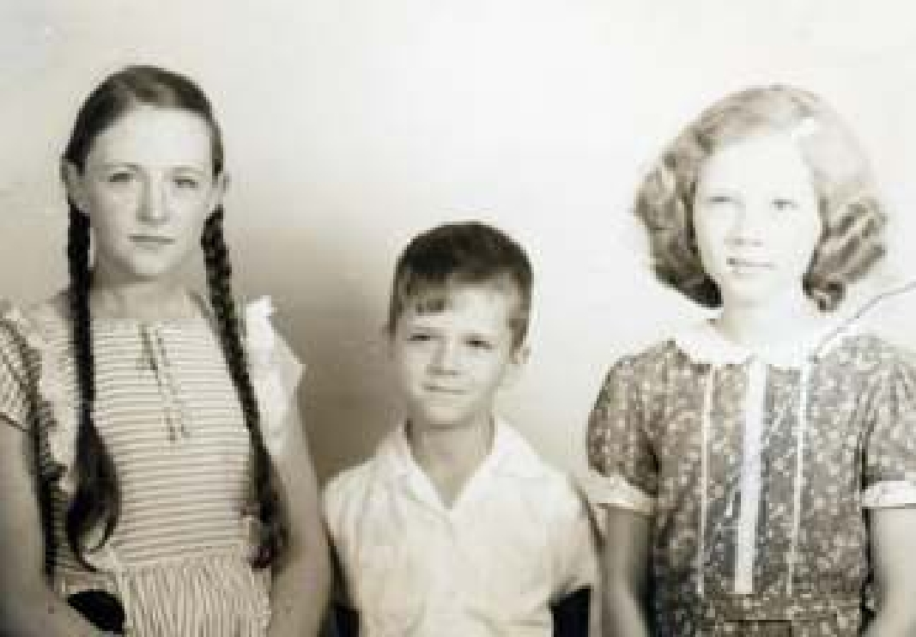
 | When we met, Alison was attractive
 | but thin and asthmatic. Even before
Carole with Robert and Alison Gray | entering school, she spent much time

indoors reading. She had a tenacious spirit and a winning way. We played on the dead-end, gravel street with the boys. She, more than I, accepted any dare and competed with zeal. Together we grew healthy and accomplished in our own ways.

A favorite game was jumping off the roof of our garage into the soft dirt in Joe’s back yard. Neighbor Joe Garrett was an only child as was I. He was physically large for his age and had both physical and learning problems. In a valiant effort to help Joe socially, his mother would make delicious graham cracker ice cream and invite all the children on Fairfax Walk and East 32nd Street. I regret to report that we would consume the ice cream and then resume our activities with very little deference to Joe.

Alas, there were other examples of unkind words and inconsiderate activity. In some I was the persecutor and in others, the victim. When Mother discovered my wrong-doing, I was punished. To my credit, I remember befriending a little Native American girl whose name was Tonka Lee. In my public elementary school the vast majority of children were Caucasian with only a few Hispanics and no Negros. Considered an oddity, Tonka Lee was being teased and taunted by some boys as she prepared to walk home from school. After witnessing this, I spent many afternoons walking the long way home with Tonka Lee.

Despite being devoted playmates, Alison and I had disagreements and even fought each other one day. The Gray’s maid reported to Alison’s mother that Alison came home crying but that Carole was all “clewed up”, or perhaps it was the other way around. The boys in the neighborhood were usually tolerant allowing us to ride bikes and roller skate with them, but we were never given permission to ride in the wooden go-cart they had built.

One not so fine day Alison’s younger brother Robert and I were considering what to do next. We found an old lipstick in the Tyson’s yard and used it to draw on the wood siding of their house. I was old enough to know the consequences, but I now rationalize that I must have been seduced by a creative urge to draw. We were seen and, to be sure, we were punished, although I can’t remember how.

Judy Tyson was younger and unwilling to accept our goading to participate in tree climbing and jumping off high places. However, she and all the children loved climbing and playing on an old flat-bed truck that my father brought into town before leaving to join the army. The truck had been used to haul cedar that was being cleared from the land on the banks of the Colorado River that my father and his partner purchased in 1939. It was only when Mother realized that the truck had a commercial permit for scarce and rationed gasoline that she approved of the unsightly vehicle parked in our back yard. During the war while others were conserving their car trips, our truck provided us with all the gasoline that we needed to keep our 1940 Chevrolet filled to the brim.

I don’t think my mother ever forgave Daddy for volunteering for military service and leaving her alone with a seven-year-old child to raise. He told her he was driving some of the younger men in his office to Waco to enlist, which was true. Although he was over forty and would not have been drafted into the armed forces, he felt it was his duty to volunteer to serve his country during the war.

Although today this country is fighting two wars with volunteer service personnel, there is very little evidence of the patriotism that I experienced as a child during World War II. Families we knew lost beloved fathers and brothers in the war. Deprivation became the norm. Much was rationed so it could be sent to troops overseas. In addition to gasoline rationing, sugar and butter and candy were in short supply. Proper women, who wore silk stockings, found them unavailable. Our mothers used leg make up that worked well until summer’s hot humid weather caused it to run. Aluminum foil from packaging was saved and rolled into big balls. Blackouts and air raids were practiced in all the cities in the United States. Because television was yet to be invented, families would gather around their radios for the latest war news and read LIFE magazine to learn about the war and to see battle photographs. The entire country was deeply involved.
My father entered the Army Corp of Engineers as a captain. By the time he left the country, he was Major McIntosh headed for Alaska which had not yet been added to the 48 United States. His battalion

Major McIntosh in the Aleutian Islands

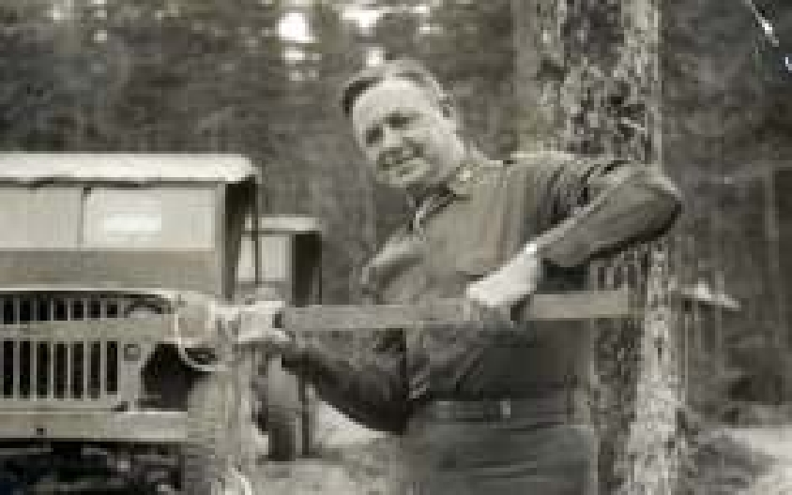
was building bridges and supply lines in the Aleutian Islands of Alaska located across the ocean (or the Bering Straits) from our enemy Japan. Mother moved my single bed into her room so she could rent my bedroom to a young female chemist. We rarely saw her because she rose from her bed at 5:00 a.m., prepared a quick breakfast in our kitchen, and drove to the magnesium plant north of town returning late in the day. Perhaps she took the job of some young man who had become a serviceman in the Army, Navy or Air Corps. And perhaps she was involved in producing something for the war effort. The magnesium plant is now the Jake Pickle Research Center belonging to the University of Texas and it is very much within the boundary of Austin.
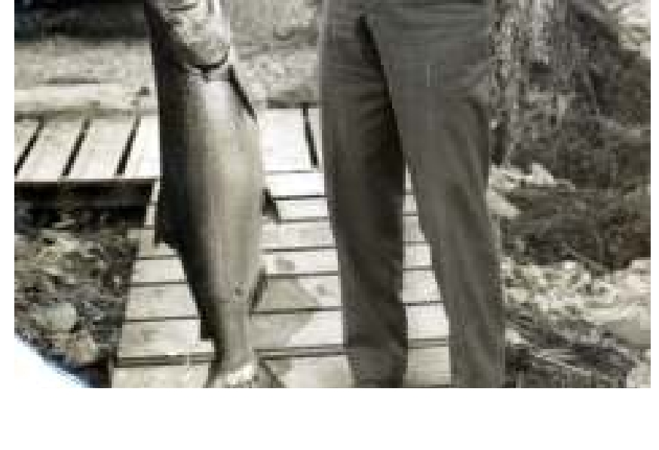
I missed my dad, but Mother often had trouble getting me to write a note to be included in her letters to him. He wrote me letters. One included a poem “Someday You Will Understand”(See Appendix) I think that because I remembered my father reading the Sunday comics to me when I was a small child and because I loved to draw, I
decorated my three ring, blue canvas, school notebook with characters from those funny papers that my father had read to me before he left to join the army.

Now I know from my experience as a mother that it is very helpful, indeed a blessing, to have a partner when raising children. The war created lots of mothers with the responsibility of raising their children alone. For a brief time my mother was a single parent in charge of discipline with no back-up from my absent father. She never believed in fighting my battles for me. When I came home in tears over an argument or when I perceived offences against me, she would say, “And what did you do?”

A fifth grade schoolmate sitting in the desk-chair behind mine was yet another boy named Bobby. One day while waiting for the teacher to return to our classroom, he yanked my long braided hair. It hurt and I angrily jumped from my chair causing him to get up and run. I ran after him, up and down the aisles between the desk-chairs. The teacher returned to find her class shouting, laughing, clapping and Carole McIntosh running after Bobby Bowen. You can imagine her reaction. She got her class under control by sentencing me to 5 weeks of staying after school. My mother did not intervene. I don’t know if the teacher ever learned that the chase was precipitated by Bobby pulling my pigtails, but she often dismissed me very soon after the last bell rang. I like to think that she realized she had overreacted. However, maybe she sent me home because she was eager to go home.

As a young elementary school student, there was great joy as well as hurt feelings when making new friends. Learning to make new friends and to love and care for those friends required giving up some of my own priorities. I’m grateful that I lived in a neighborhood with so many children because I had no brothers or sisters with whom to learn sharing. Although children in the 1940s did not have as many toys and assets as children do today, those that I had were all mine. I’m happy to report that many of these early friendships made at Robert E. Lee Elementary School still endure. Alison Gray Kimberlin, Margaret Olle Womack, Jodie Roberts Ellis, Ruth Prouse Morgan, and Wallace Showalter are part of my world today.
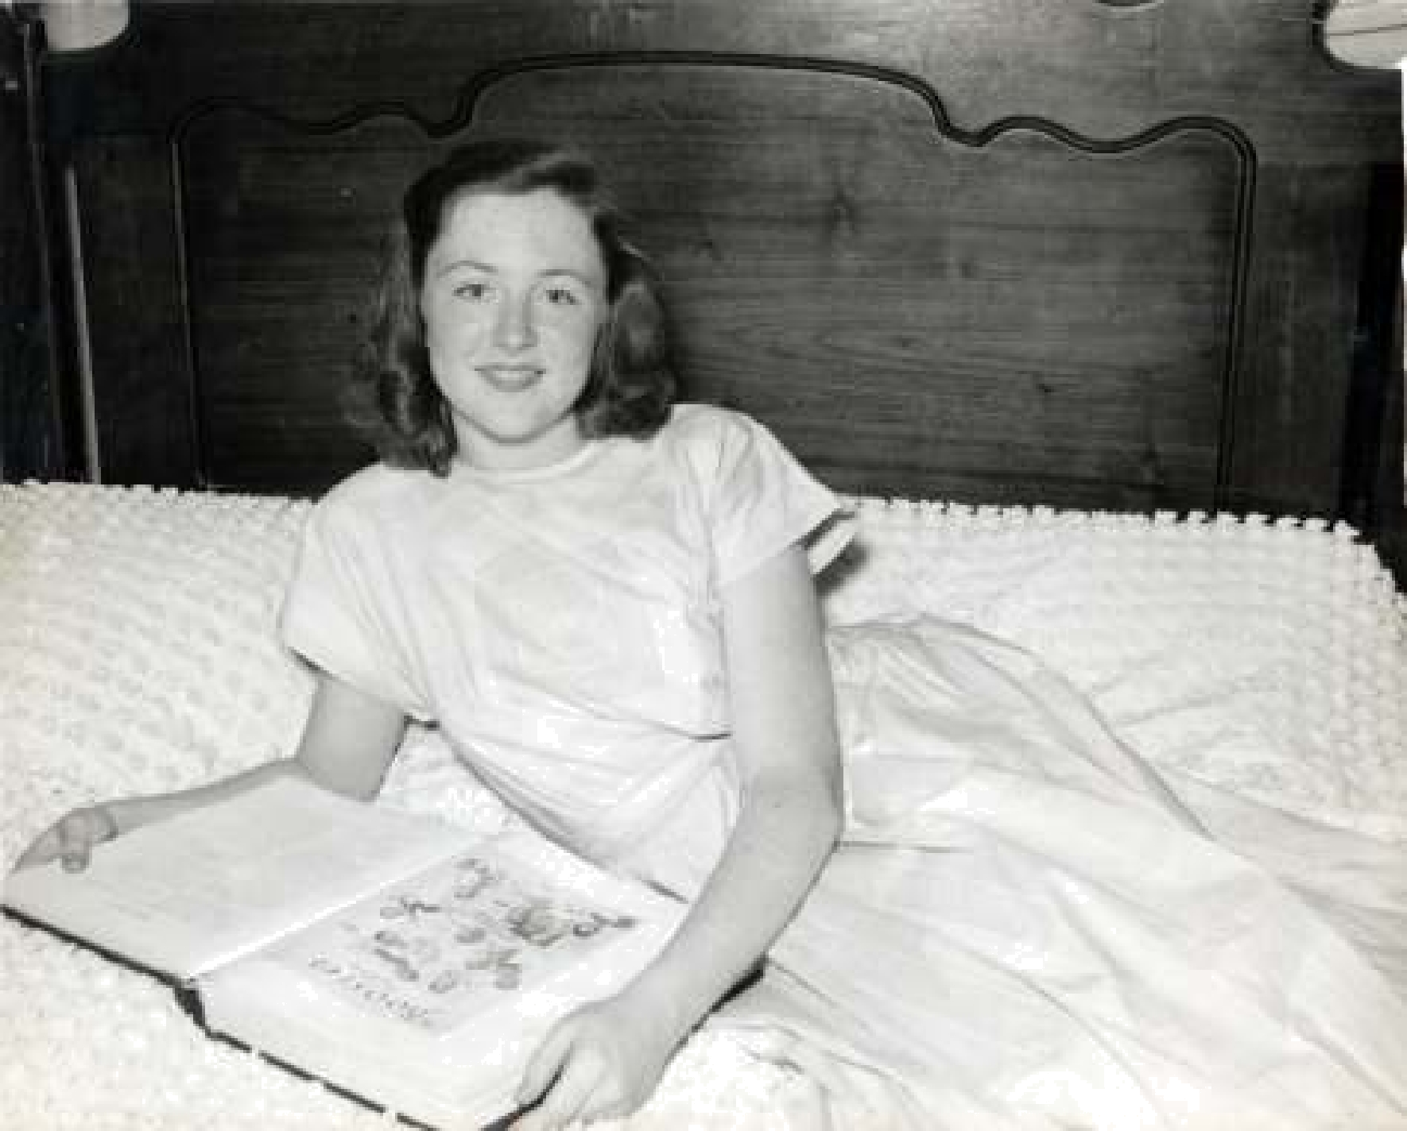

The Teen Years

In 1946, I entered University Junior High School without pigtails but still in gingham dresses made by my mother. There were many new, different, and more sophisticated classmates. It was a difficult time for me. Mother and I were adjusting to having my father home from the army. As wonderful as it was for me to have a daddy again, it was different. He was different, and I was not the same little girl he left behind. My interest in art, in drawing, was a consolation during these difficult middle school years.

My mother had been saving money from my father’s military allotment and had selected a residential lot in west Austin on which to build a new home. Shortly after Dad returned, the lot was purchased, plans were drawn, and a contractor was engaged to build our home in Tarrytown.

At the same time my father started building our weekend house on Pool Canyon Cove in the new Hudson Bend Colony that he and his partners had created. The Lake Travis subdivision was created from the Joe and Emiline Williams’s family farm purchased by my father and a partner in 1939. After the completion of Mansfield Dam on the Colorado River half of the 700 acre farm was inundated. Regretfully, my father was away and missed seeing the waters flow over his land to form the new lakefront subdivision for “vacation cottages”. However his partner wrote to him in Alaska with a glowing description of the seemingly miraculous event. (See Appendix)

When my father returned to civilian life, Mother and I were living in a house on Speedway Avenue. From there the three of us moved to the not-yet-completed weekend house on Pool Canyon Cove twenty-two miles from Austin. For nine months while building our home on Tower Drive in west Austin, we lived on Lake Travis in one big room plus a kitchen, sleeping porch and a bath. It was a
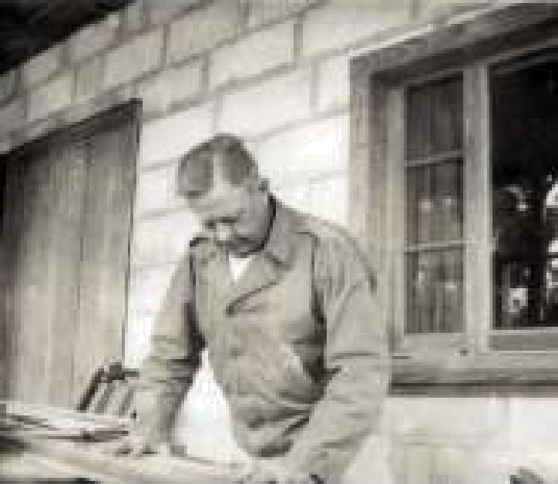 | time for becoming a family again. On week days I rode
 | into town with my father. He took me to my school and
 | then drove downtown for his work. Mother stayed in the
 | country to meet the workers who were completing the lake
 | house or she drove into town to select fixtures for the new
 | house in Tarrytown.
 | We were now a two-car family. My father was using the
 | car furnished to him by the state of Texas and my mother
 | was still driving our old pre-war, 1940 Chevy sedan much
 | to my embarrassment. On weekends all three of us were
 | in the country with my father happily involved with
 | various projects. I’m sure that my mother was relieved
 | when our home in town was finally ready for us to take
 | possession. I’m equally sure that my father had mixed
 | feelings. His heart was at Lake Travis and he continued to
 | spend as many weekends as possible on the land beside the
 | lake that he had dreamed about during those years when
 | he was away.
 | Moving back to town was an opportunity for me to reenter
 | the world of my peers. Instead of doing my homework at
 | my father’s downtown office before we drove to the lake
 | to join Mother in our one-room lake cabin, I had my own
 | bedroom. It was my own space in which I could do my
Our first Lake House | homework, entertain my girlfriends, and have time to
Our first Lake House | myself.
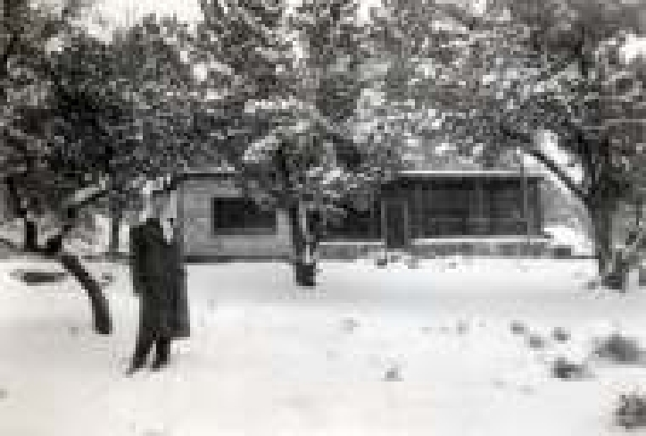
Clare Coates and her family lived on Townes Lane behind our new house at 2401 Tower Drive, and we became great friends and remained close until her death in 2009. Our parents took turns driving us to school. Clare’s father built a stile over the tall wall that divided our back yards so we could visit each other more easily. Clare also loved to draw, and we spent many hours on shared art projects during our years in University Junior High School and later in Austin High.

Another good lifelong friend, Claire Caswell, had a great aunt, Helen Caswell Gerhardt, who was my mother’s friend. Claire and her mother and brother lived with “Nen” on West Avenue for a few years. At the time we met, Claire was in Pease Elementary School and we had very little in common. Pease girls seemed very sophisticated and not until later did Robert E. Lee and Wooldridge girls catch up to them.

The middle-school years in University Junior High School had not been particularly happy years for me. The reentry of a father into my teenaged world, the changing from Lee Elementary to a larger school with new faces and names to learn and new friends to make, not to mention the often documented changes of puberty during the teen years made my transition uncomfortable and difficult.

In contrast Austin High School was wonderful for me. My expanded band of girlfriends and I belonged to an organization called Red Jackets. We wore maroon and white uniforms and marched with the band at football games during the halftime. Frequently after a game there would be a slumber party. If not, I might stay overnight with Louann Atkins or Jo Betsy Lewallen at their homes or they with me at my home. For the out-of-town games there were two Red Jacket buses as well as the buses for the band and football team. Red Jacket officers for our senior year were Claire Caswell, Alison Gray, Margaret Olle, Josephine Klotz, and Clemmie Faulk. I, along with friends Patricia Robinson and Ann Harrell, was among those who were nominated for a Red Jacket office but lost. On the evening after the winners were announced, Pat in her blue Chevy convertible arrived with Ann to pick me up. We drove around town shouting, laughing and weeping in an attempt to console ourselves and each
other. My consolation came when Claire, who was president, asked me to ride with her on the front seat of the Red Jacket bus. Perhaps she was sensitive to my disappointment at not being elected to office. Her kindness helped enormously to assuage my hurt feelings.

In Austin, Texas at this time young people reaching the age of fourteen could apply for a driver’s license. However, a hardship had to be approved, a written test taken and a practical driving test passed with a patrolman in the passenger seat. The creative descriptions of hardships were amazing. Most of us who were licensed early borrowed our mothers’ cars but a few had cars of their own. We loved to hang out at drive-in hamburger restaurants, drive-in movies, or we just drove around to celebrate our freedom. On Sunday afternoons we gathered in Claire’s upstairs bedroom to visit, gossip and smoke cigarettes. Claire’s was the only mother who allowed smoking. Mrs. Sharp knew we were smoking, as I suppose all our mothers did when we returned home smelling of cigarettes, but she believed we were safer in Claire’s room than driving all over town in cars while smoking and talking and laughing. We believed that smoking cigarettes was our great secret rebellion. When smoking in public places, we were cautious for fear of being seen by friends of our parents who surely would report us.

In the summer there were wonderful places in Austin to meet for swimming. Our favorites were the public pools, Barton Springs and Deep Eddy, and the lakes nearby. Nancy Ritter’s family had a boat on Lake Austin, and she taught us to water ski. Margaret Ann Olle’s family also had a lake house on Lake Travis. One summer many of us decided to take morning classes in summer school. After classes let out, we would pile into Suzanne Ashford’s 1950 chartreuse Ford convertible with our swim suits, Dr. Peppers and tuna fish sandwiches, and head for Eck Lane on Lake Travis. The Olle’s weekend neighbors on the lake had a covered dock which we occupied on the week days when they were not there.
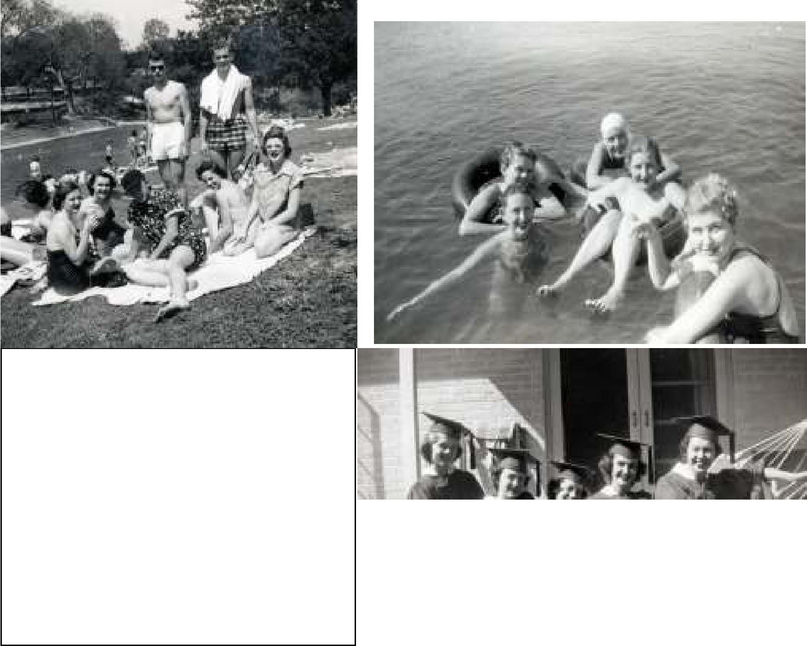

Barton Springs (L to R) Carole, Louann,
Henry, Leslie, Barbara, Charles, Jo Betsy

Lake Travis Carole, Alison, Patsy, Claire,

Mary

McIntosh House 2401 Tower Drive Alison,
Carole, Barbara, Louann , Clare
Dating

Dating at an early age in University Junior High School meant being driven by the boy’s parents, usually to and from dances, but occasionally to a movie. We wore long, strapless, tulle dresses with gardenia corsages pinned wherever we could find a place or wrapped on our wrists. Even in high school in the 1950’s, dating meant simply “going out” with someone as opposed to “going steady”. Charles Sikes, with his parents, had been “dating” for several years. Pease Elementary was the social school where punch made with lime sherbet and ginger ale was served at tea dances on the weekends. My elementary school was inhabited primarily by children of University professors and parents who were not interested or not able to prematurely advance their children socially. We played Spin The Bottle and ate Frito Pie at our weekend parties. It was not until Junior High School that I had a dance party date with a boy and a gardenia and his parents.

I had noticed Charles at dances in junior high school because he “dated” several of my young girlfriends. In high school it took a considerable amount of cunning on my part to be noticed by him, but notice he did. We were now in high school, free from parents in the front seats and on the side lines at dances. We were having car dates with boys to football games and movies. Most dates were double dates in borrowed cars, especially when couples were not “going steady.”
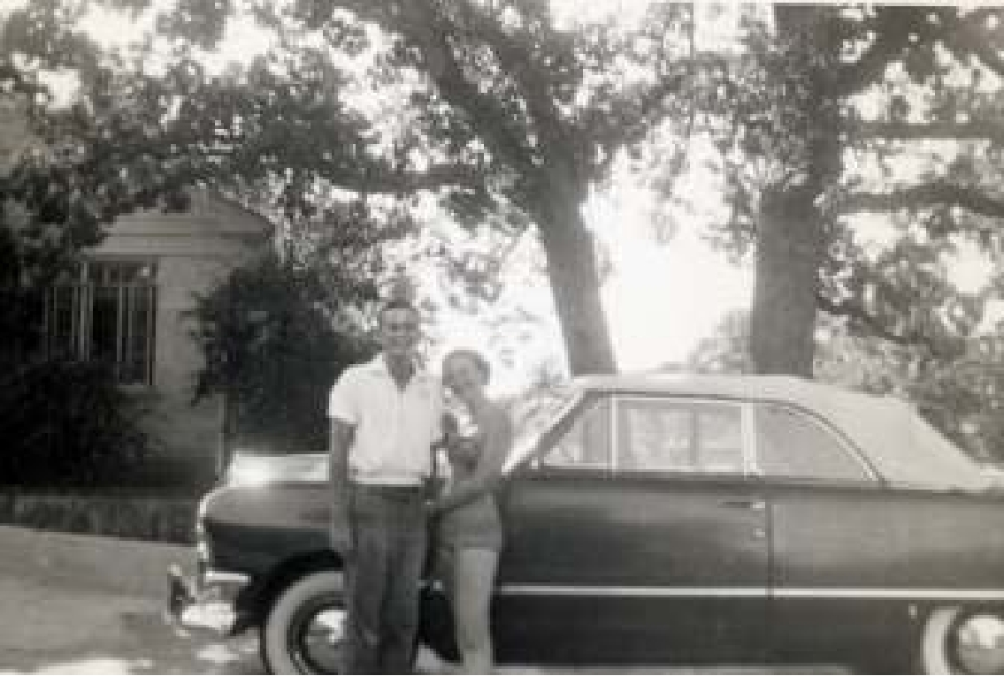

Charles had his own car. We never dated exclusively. For me there was also Bill Staehely and Tommy whose last name I have forgotten and a few others. Charles had lots of girl friends but because we had so much in common to laugh and talk about, we became best friends. It was a long time before we were ever lovers. That came much later. Even at an early age we shared an interest in art and architecture and we would share our drawings. His were usually of houses he had designed. It was no surprise to me when I learned that he would major in art while I majored in art education at the University of Texas in Austin.

Charles and I both lived at home as did all of my friends who stayed in Austin to go to the University of Texas. High school was great but college was even more wonderful. Charles and I continued to date throughout our college years, but still not exclusively. I would frequently ride home with him from an afternoon art lab. We would stop by “Dirty” Martin’s Drive In, where I learned to drink beer. When I arrived home, I would need to take a quick nap before having dinner with my parents. I heard my mother comment to a friend, “Carole is working so hard that she has to nap when she comes home from her afternoon classes.” Little did she know that I was sleeping off my half glass of beer that I shared with a boy who would one day become my husband.
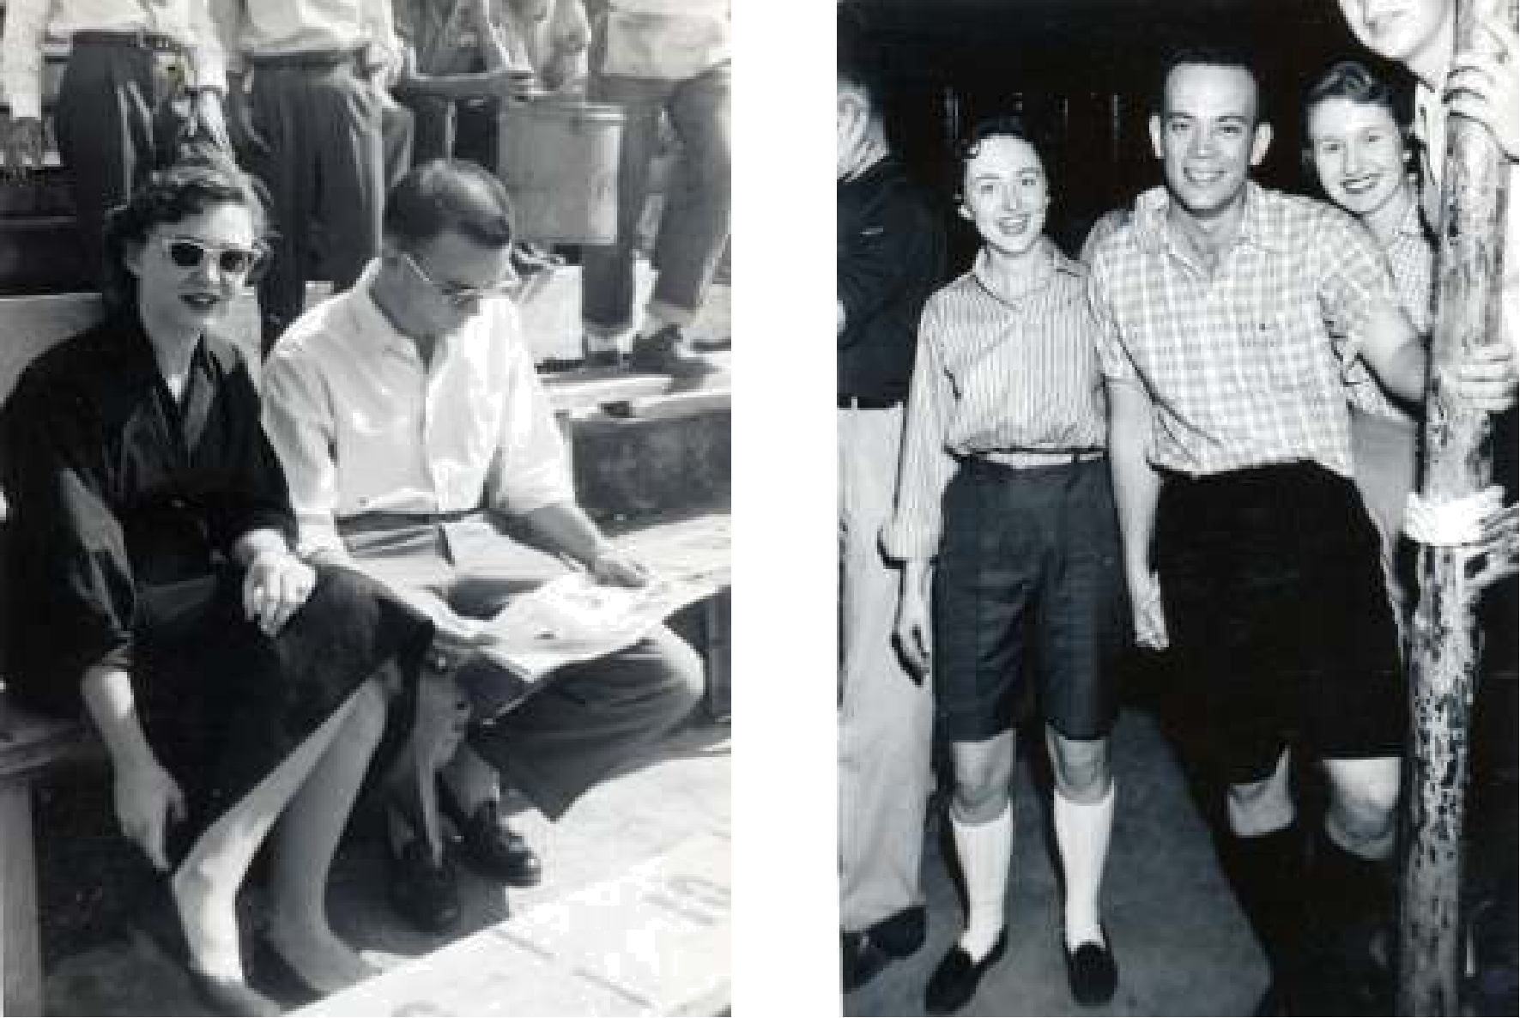

The University of Texas Football Games, Fraternity Parties, Sorority Rush Parties
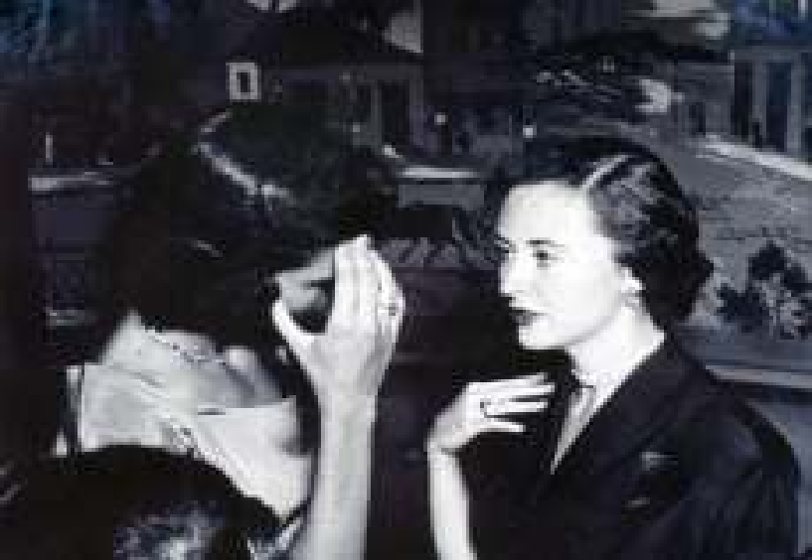

Several of my high school friends pledged Chi Omega sorority with me.

There was Louann Atkins, Nancy Ritter, Suzanne Ashford, and Barbara Draper. Jo Anne Boykin came from Christian College in Missouri, and the next year Jo Betsy Lewallen returned from Baylor to join us. Other friends were Thetas, and a few pledged Pi Phi and other sororities. There were wonderful sorority sisters with whom lifelong friendships were formed, especially June Lakenmacher Adamsfrom Houston. Classes were challenging and learning was compelling and fraternity parties were great fun. I continued to enjoy it all while completing a Bachelor of Fine Arts degree in 1956.
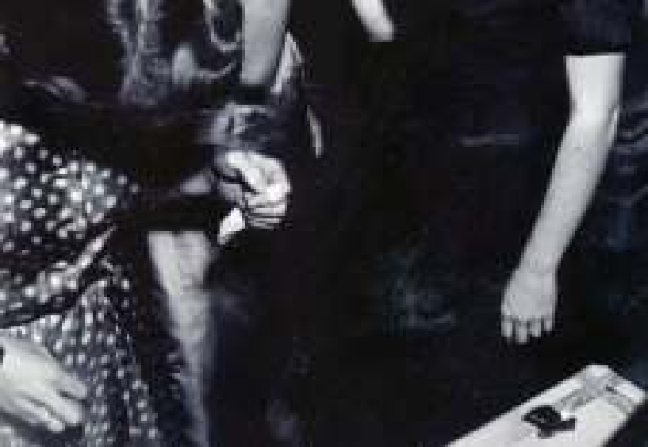
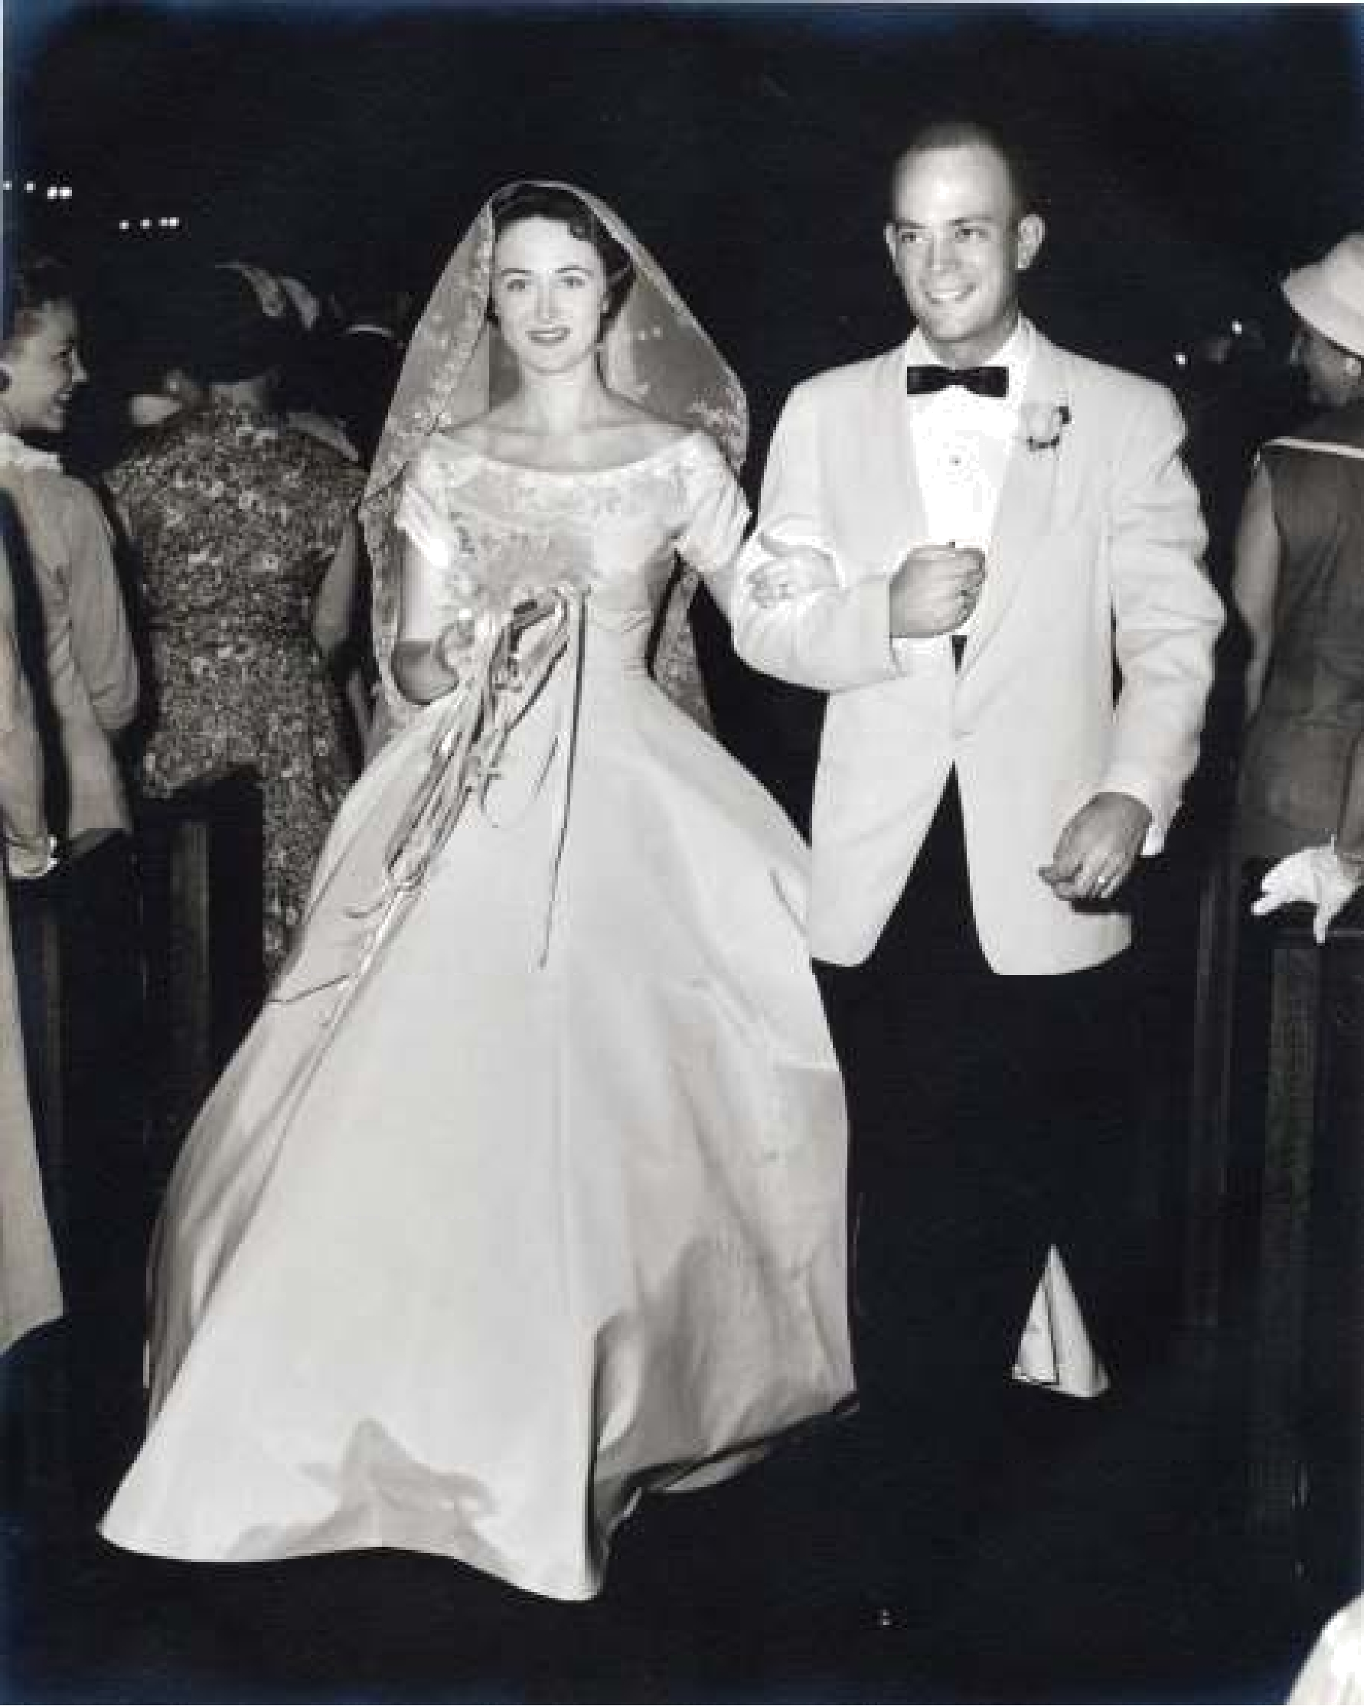

Our wedding at The Episcopal Church of the Good Shepherd June 21, 1958
Marriage and Motherhood

Not until I graduated from the University, leaving Austin first for a summer semester at Columbia in New York and then for a teaching position in San Antonio, did I begin to realize that something essential in my life was missing. It was Charles. He had been my very best companion for many years with whom I could share everything that was important as well as much that was not. While I was teaching art in San Antonio, Charles was satisfying the mandatory requirement for young men to serve their country. He served six months of active duty at Fort Smith Arkansas and later five and one half years in the Army Reserve. Our country was not at war so he was able to join his parents in their Austin retail business and to begin our marriage while attending weekly meetings and summer camps as a second lieutenant in the U. S. Army Reserve.

After many love letters and frequent weekend trips between Austin and San Antonio, we became engaged. I then returned to Austin as art teacher at Baker school. On June 21st, 1958, two years after graduating, we were married at the Episcopal Church of the Good Shepherd with Alison Gray Kimberlin as my matron of honor and bridesmaids Louann Atkins, June Lakenmacher Adams and Jo Betsy Lewallen. Bill Staehely was best man for Charles.

While learning to be a wife, I continued teaching in the public schools. During a summer vacation I helped at the Sikes family’s Bo-Peep Shop only to learn that I was not a retailer. Exhausted and discouraged I gave up public school teaching but continued working on a graduate degree in painting and printmaking. Along came motherhood and my induction into the Austin Junior League. Laura arrived in l962, and two years later I gave birth to Stuart shortly after completing the last of my course work for my master’s degree. Several mornings a week I left our babies with maids or sitters to teach painting and drawing to little old ladies in tennis shoes at Austin’s Museum School of Art at Laguna Gloria. In the afternoons while our children slept, I painted in my studio at home and was exhibiting my work in galleries around Texas. In the evenings I played with the children in the parks and in our yard and prepared for our dinner with their daddy Charles. After a busy ten years and a very good life in Austin we moved to Dallas.

It was 1968 when Charles accepted a position as director of One Main Place Gallery in downtown Dallas. After a year we returned to Austin to purchase the Bo-Peep Shop from the senior Sikes who were retiring. Charles managed the big store and also established the two smaller Expecting The Best stores. I became a full time mother and a part time community volunteer while we continued to raise our family and enjoy our friends in west Austin.

As I complete this story, it is now the year 2011. Twenty years ago Charles and I moved from our home at 4513 Balcones Drive to my parents’ retirement home on Lake Travis. Now it is we who are retired from all but making paintings in our studio and serving God in his church and grand-parenting our five grandchildren. We both are practicing artists and happy grandparents to you Dallas Sikes, Caroline, Sidney, Charlie, and to you Austin Barrows, Angela and Michael. Our beautiful and unpretentious college town, home of the University of Texas and capitol of our state government, has been proclaimed one of the nation’s best cities in which to live which of course we have known all along. The many, many newcomers are transforming it into a very big city. So this is my story of growing up in a town that no longer exists. I hope you will enjoy this grandmother’s personal history of her beloved Austin.

Appendix
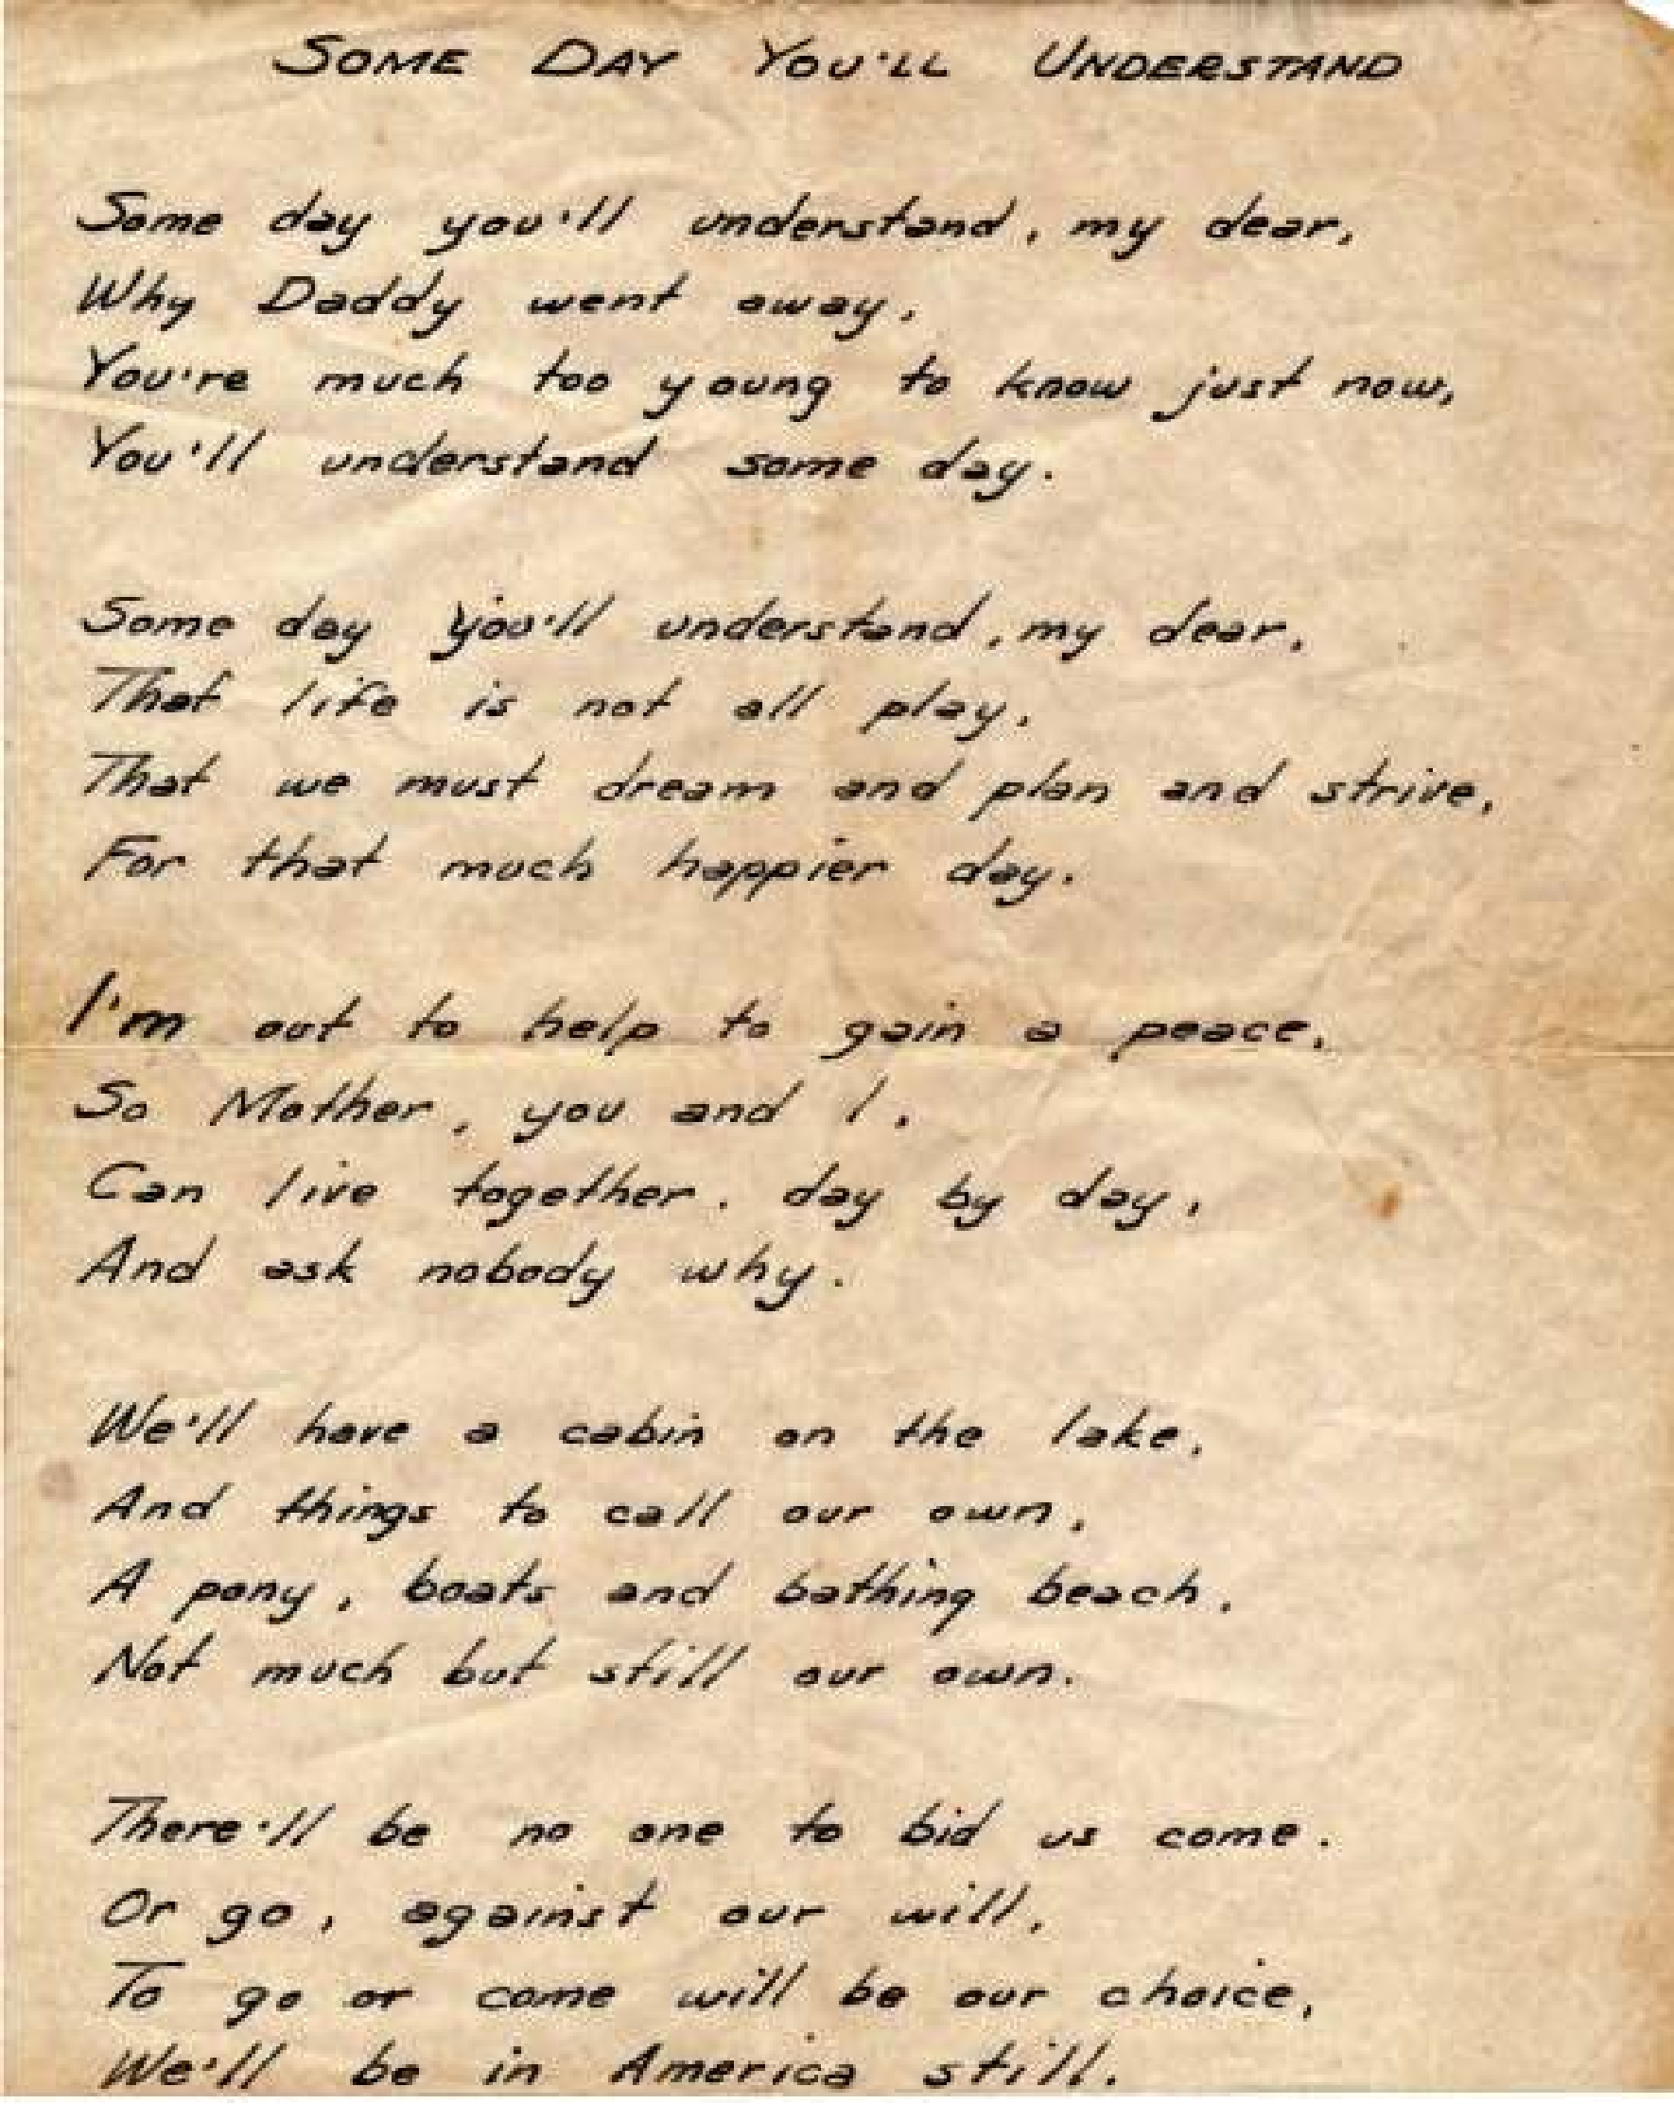
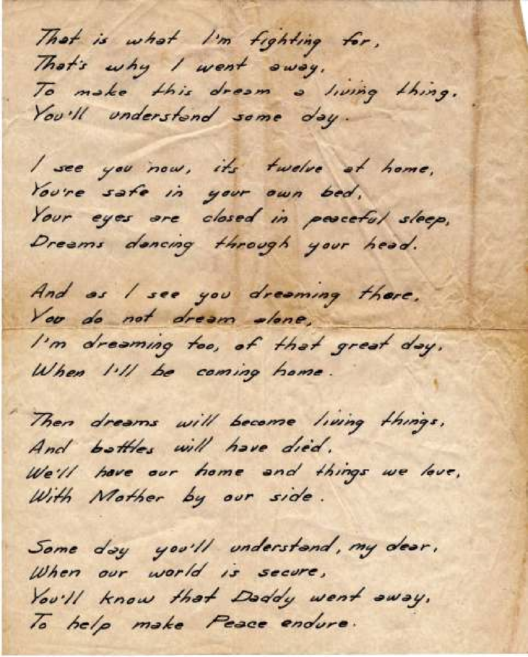

Excerpts from a letter to my father, Major S. C. McIntosh, stationed in Alaska during World War II. The letter is from H.M. Webb, his partner in their Lake Travis project, dated December 16th, 1942

Dear Mac:

Your somewhat belated but none the less appreciated and interesting letter (was) received a day or two ago. Of all the places in this wide world to which our brave soldiers are being sent to unfurl the Stars and Stripes and stop the bloodthirsty Japs and Germans, it seems to me you are very fortunate indeed in being sent to the “land of the midnight sun and the aurora borealis…”

…and when you return to civilization you will find new wonders to behold, from which you will never again want to roam.

The rough and rocky shores of Lake Travis have been transformed, and the places you once knew are no more—they are all covered over in our own made to order fashion with crystal clear, blue water, which magnifies gorgeous sunsets and makes more beautiful and impressive the big yellow moon as it slowly rises in splendor to cast its very obliging, mellow beams across the hills for lovers to bill and coo. All of the ugly places have been completely erased, and only the beauty spots remain, justifying your far sighted vision and for you to enjoy as your tender, youthful years lengthen into a complacent old age. But judging from the picture you recently sent to Georgia, I must not be talking to you, for that picture betrays the youth.

My idea is that the country, in which you are now so pleasantly encamped, is no doubt very beautiful…but every day it is the same old view… snow does not change in color-its always white. It will sooner or later grow monotonous, and you will then understand and appreciate that its just a place to go and see, while your own home sweet home on Lake Travis is a place to live and die.

Remember too, the same old sun… (In Alaska) ...also paints its pictures in variegated colors across the ever changing green clad hills of Lake Travis. Here, as the seasons come and go, and the leaves change their colors, by reason of which the sunsets change their colors too, there will be no monotony, and nowhere on earth will you ever see sunsets more beautiful.

Bull aside—our business affairs are at a standstill. While matters are not as I would have them, still I believe you realize how hard it was to accomplish anything with divergent ideas and opinions, some of which were flavored with hostility. **Under the circumstances I suppose, to wait for your return is all we can do.

**This is reference to a third partner who bought a major interest in the Hudson Bend Colony subdivision project while McIntosh and Webb owned the 200 acre Tongat property together and separate from the Hudson/Williams property.
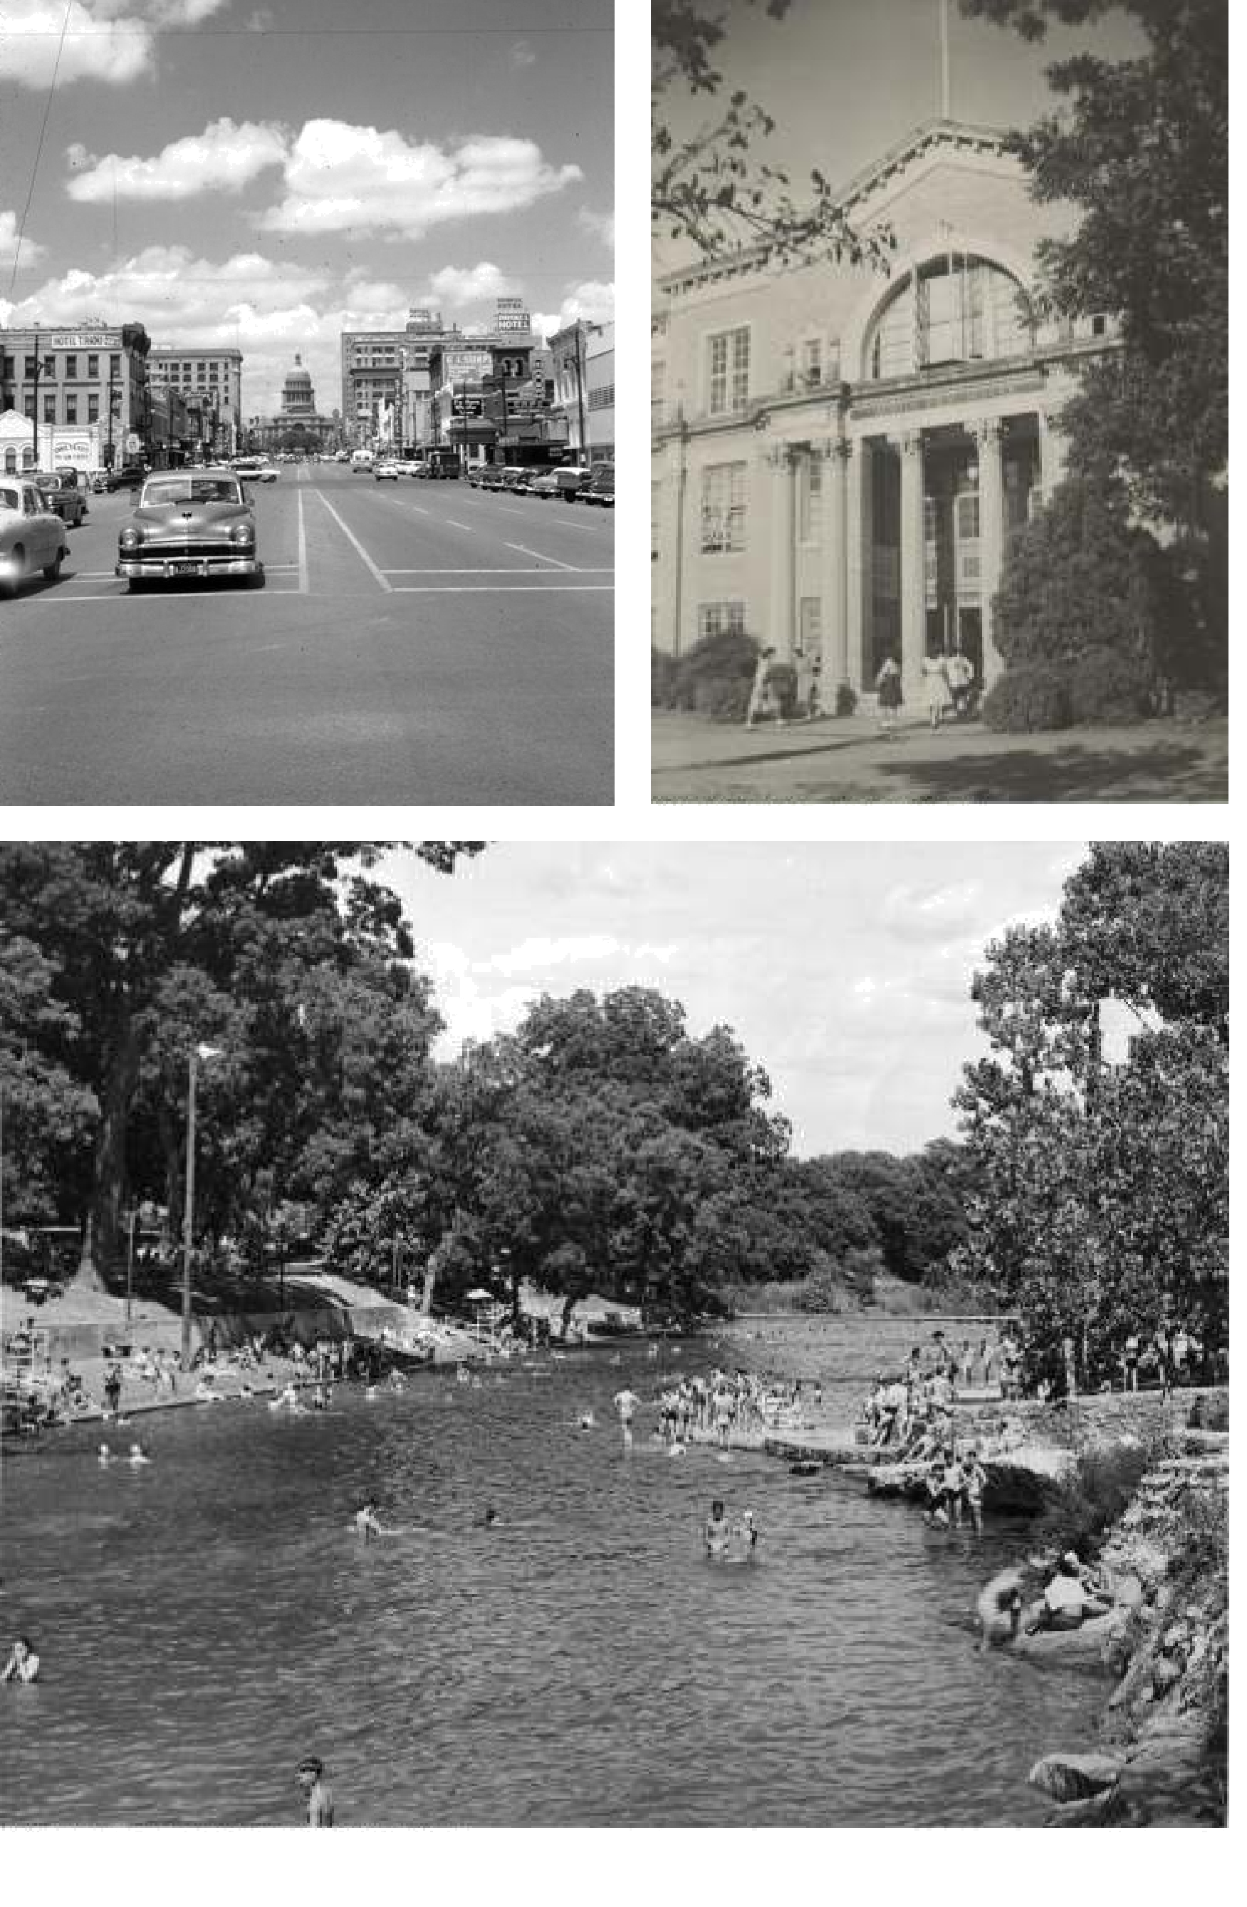

Photos from the 1950s (L to R) Congress Avenue Austin High School Barton Springs Pool

